PIZZA SALES SQL QUERIES

- KPI’s:
- Total Revenue:
SELECT SUM(total_price) AS Total_Revenue from pizza_sales

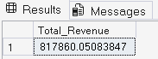

- Average Order Value :
SELECT SUM(total_price) / COUNT (DISTINCT order_id) As Avg_Order_Value from pizza_sales

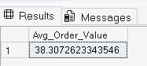

- Total Pizza Sold:
SELECT SUM(quantity) as Total_Pizzas_Sold from pizza_sales

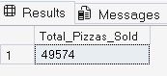

- Total Orders :
SELECT SUM(total_price) / COUNT (DISTINCT order_id) As Avg_Order_Value from pizza_sales

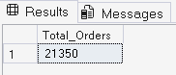

- Average Pizza Per Order:
SELECT CAST(CAST(SUM(quantity) AS DECIMAL (10,2)) /
CAST(COUNT (DISTINCT order_id) AS DECIMAL(10,2)) AS DECIMAL(10,2))AS AVG_PIZZA_ORDER from pizza_sales

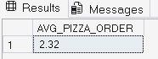
DAILY TRENDS FOR ORDERS

- TOTAL ORDERS BASED ON WEEK DAYS :
SELECT DATENAME(DW, order_date) as ORDER_DATE, COUNT (DISTINCT order_id) as Total_orders from pizza_sales
GROUP BY DATENAME(DW, order_date)

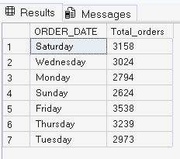

- TOTAL ORDERS BASED ON MONTH :
SELECT DATENAME(MONTH, order_date) as MONTH_NAME, COUNT (DISTINCT order_id) as TOTAL_ORDERS from pizza_sales
GROUP BY DATENAME(MONTH, order_date)
ORDER BY TOTAL_ORDERS

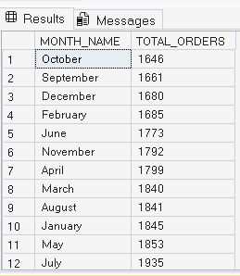

- PERCENTAGE OF SALES BY PIZZA CATEOGRY:
SELECT pizza_category , SUM (total_price) AS TOATAL_SALES ,SUM(total_price) * 100 / (SELECT SUM(total_price) from pizza_sales)
AS PERCENTAGE_TOTAL_SALES from pizza_sales
GROUP BY pizza_category

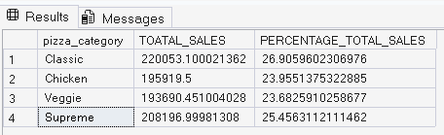

- PERCENTAGE OF SALES BY PIZZA SIZE :
SELECT pizza_size, SUM (total_price) AS TOATAL_SALES ,CAST(SUM(total_price) * 100 / (SELECT SUM(total_price) from pizza_sales)
AS DECIMAL (10,2)) AS PERCENTAGE_TOTAL_SALES from pizza_sales
GROUP BY pizza_size
ORDER BY PERCENTAGE_TOTAL_SALES DESC

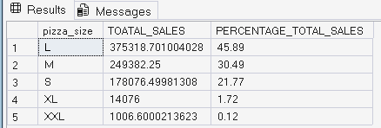

- TOTAL NO. OF PIZZAS SOLD BY EACH CATAEGORY :
SELECT pizza_category , SUM ( quantity ) AS TOTAL_SALES from pizza_sales
GROUP BY pizza_category
ORDER BY TOTAL_SALES DESC

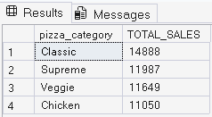

- TOP 5 PIZZAS BASED ON RFEVENUE :
SELECT TOP 5 pizza_name , SUM (total_price) As TOTAL_REVENUE FROM pizza_sales
GROUP BY pizza_name
ORDER BY TOTAL_REVENUE DESC

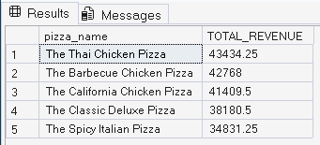

- BOTTOM 5 PIZZAS BASED ON REVENUE:
SELECT TOP 5 pizza_name , SUM (total_price) As TOTAL_REVENUE FROM pizza_sales
GROUP BY pizza_name
ORDER BY TOTAL_REVENUE

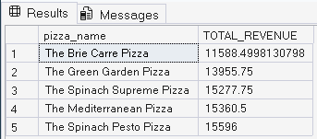

- TOP 5 PIZZA BY QUANTITY:
SELECT TOP 5 pizza_name , SUM (quantity) As pizza_sold FROM pizza_sales
GROUP BY pizza_name
ORDER BY pizza_sold DESC

